*DBMS LAB-0*

1. Create and display 5 records for students using file handing.

*SOURCE CODE*

#include <stdio.h>

#include <stdlib.h>

struct student

{

int rno;

char name[size];

int marks;

} s[5];

int i;

void create()

{

FILE *fp;

fp = fopen("d1.txt", "w");

for (i = 0; i < 5; i++)

{

printf("\n Enter roll no : ");

scanf("%d", &s[i].rno);

printf("\n Enter name : ");

gets(s[i].name);

scanf("%s", &s[i].name);

printf("\n Enter marks (out of 100) : ");

scanf("%d", &s[i].marks);

fwrite(&s[i], sizeof(s), 1, fp);

}

fclose(fp);

}

void show()

{ FILE *fp1;

fp1 = fopen("d1.txt", "r");

printf("\n Roll no : \t Name : \t Marks : \n");

for (i = 0; i < 5; i++)

{

while (fread(&s[i], sizeof(s), 1, fp1))

{

printf("\n %d \t\t %s \t\t %d \n", s[i].rno, s[i].name, s[i].marks);

}

}

fclose(fp1);

}

void main()

{

int x;

do

{

printf("\n Main Menu\n");

printf("\n1. Create Record\n");

printf("\n2. Show Record\n");

printf("\n3. Exit\n");

printf("\n*************************************\n");

printf("\n Enter your choice : ");

scanf("%d", &x);

switch (x)

{

case 1:

create();

break;

case 2:

show();

break;

case 3:

exit(0);

break;

} }

while (1);

}

*OUTPUT*

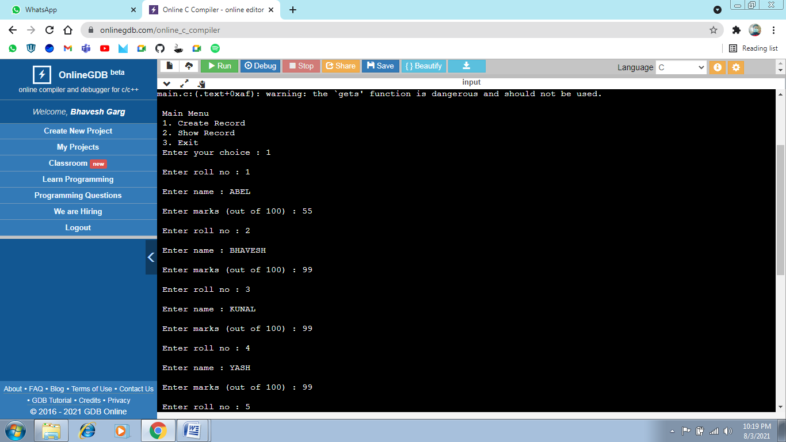

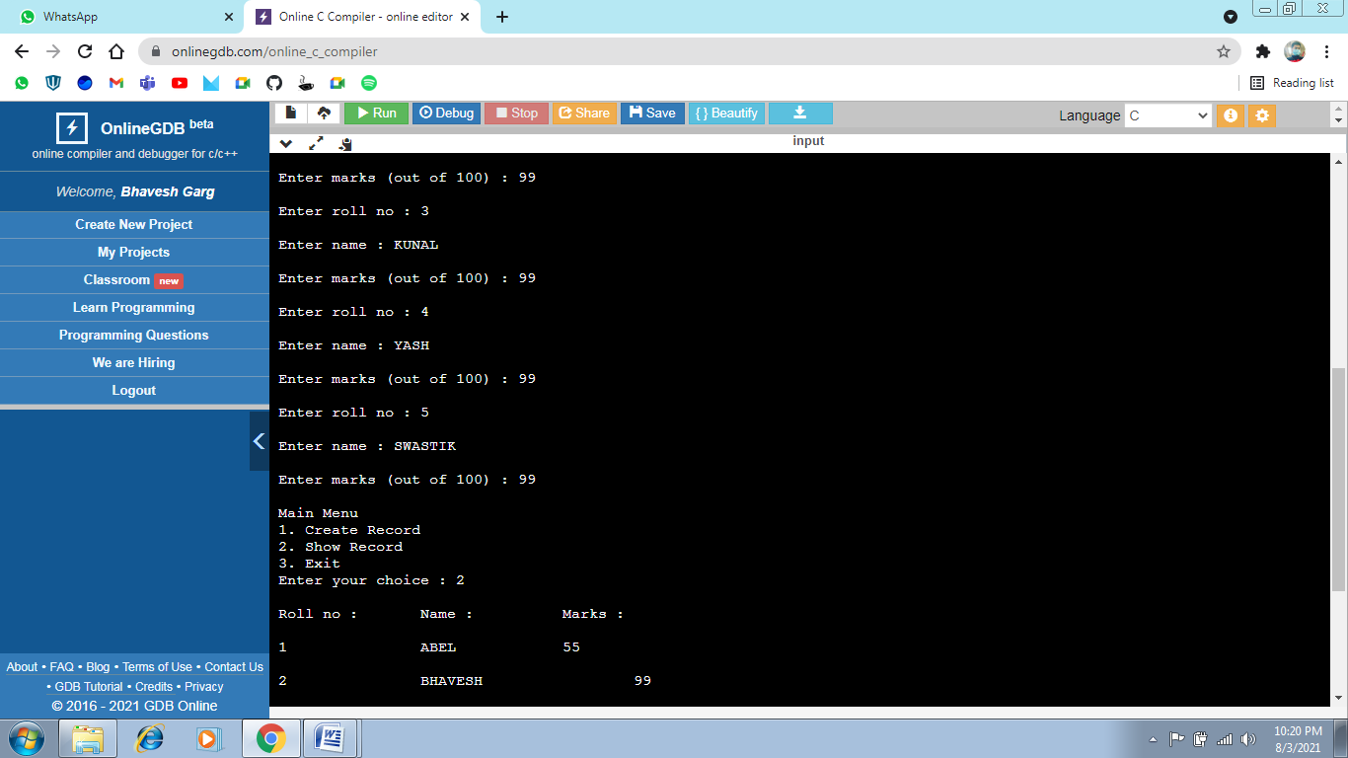

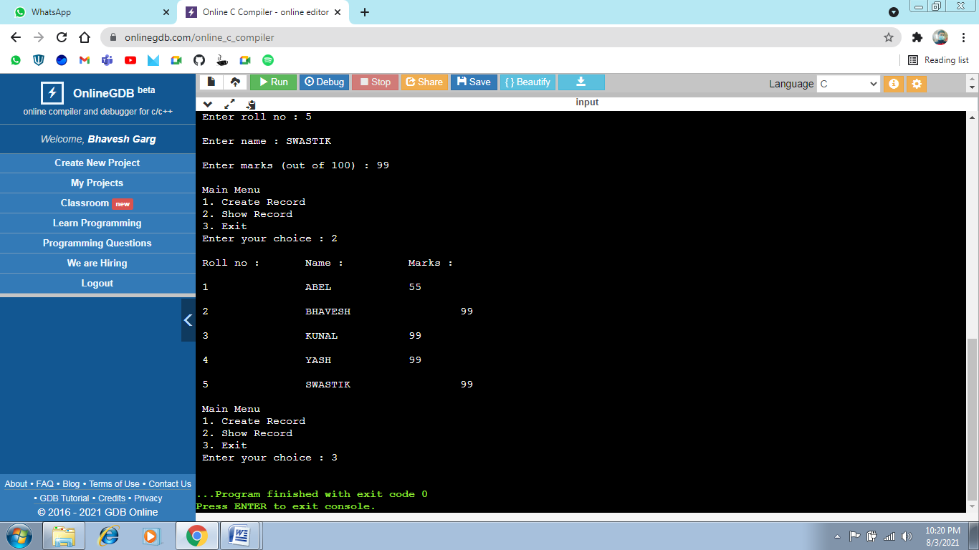

*FILE*

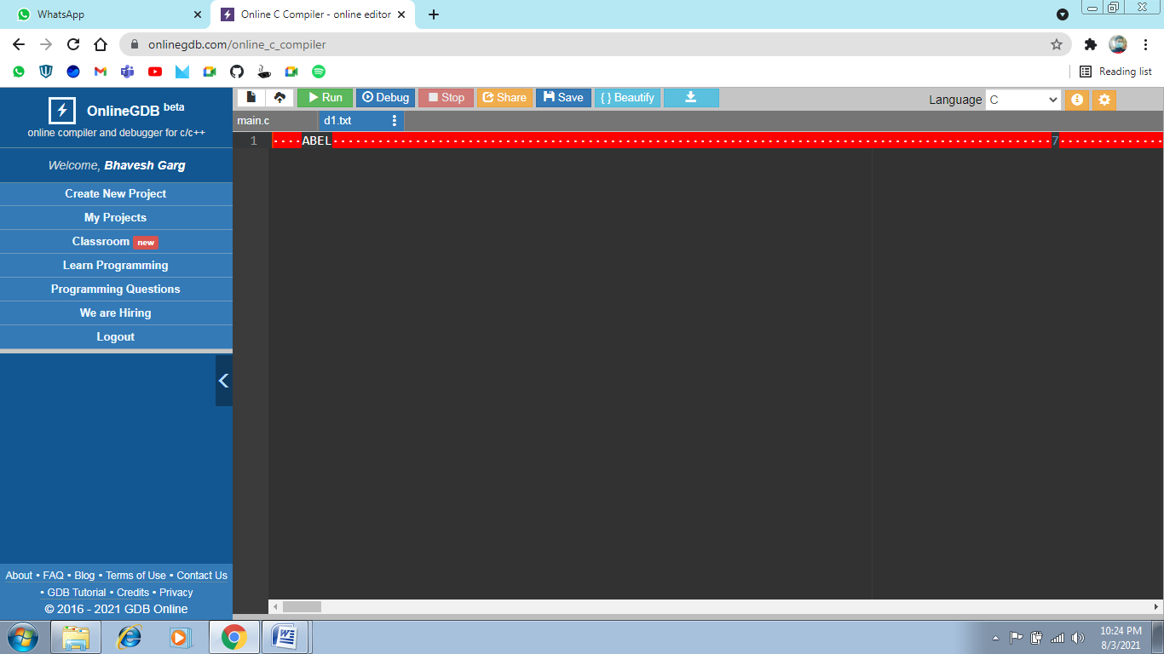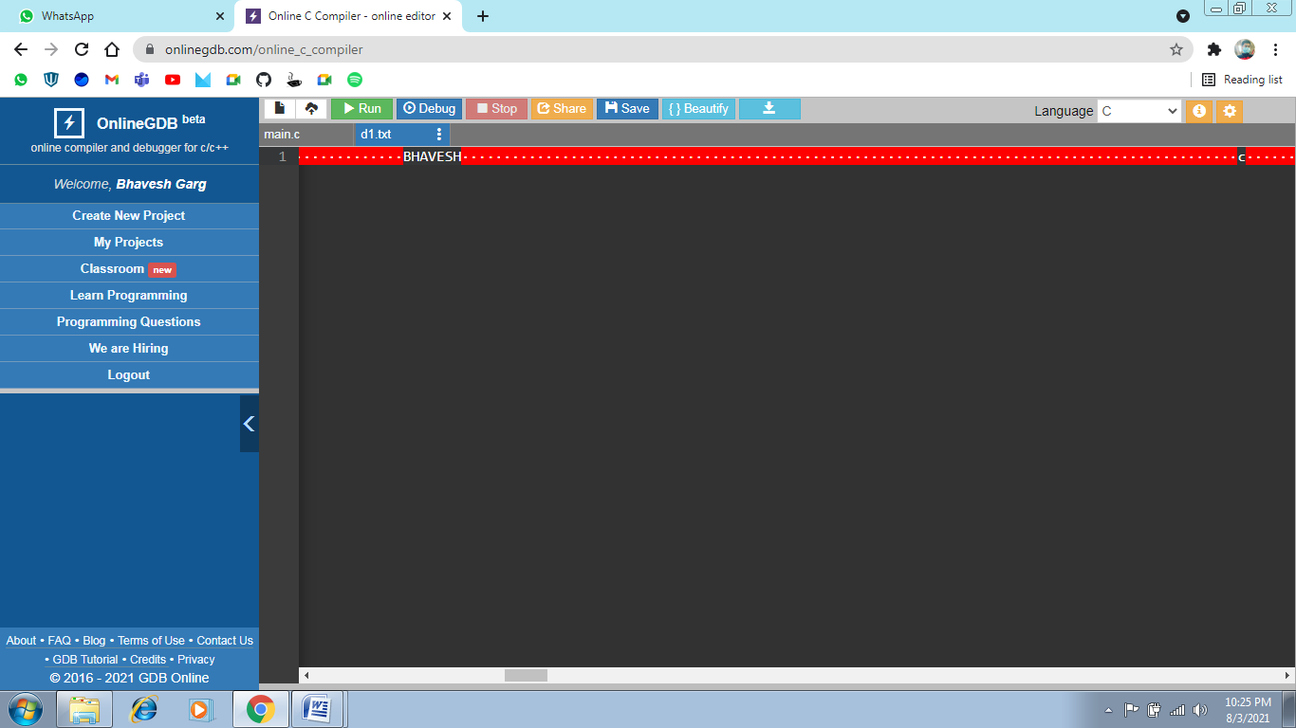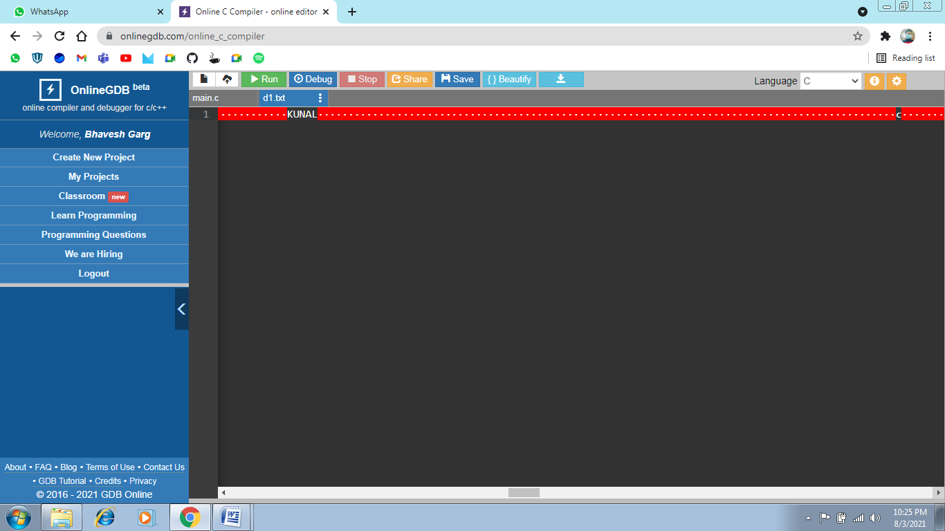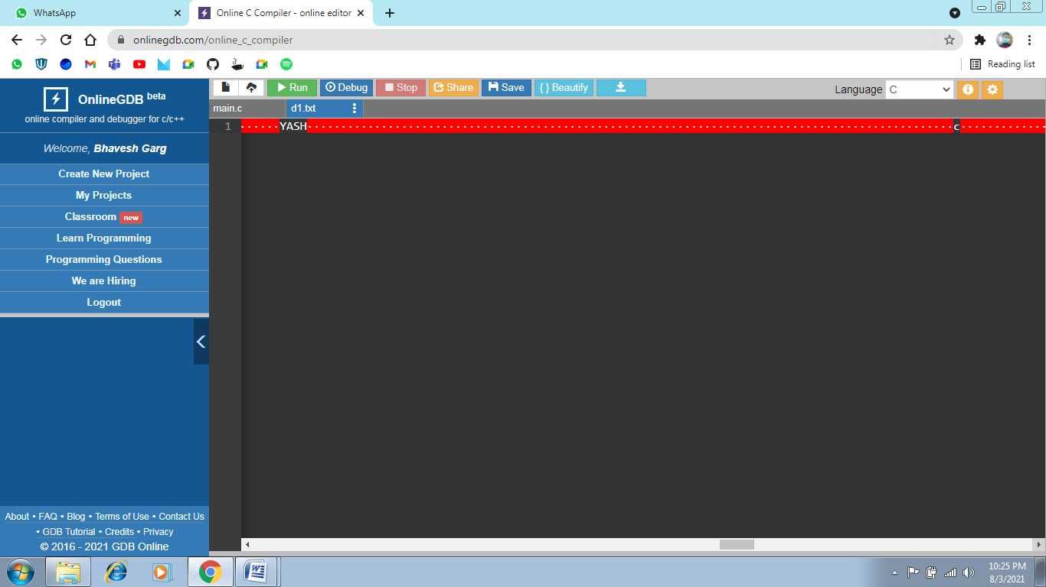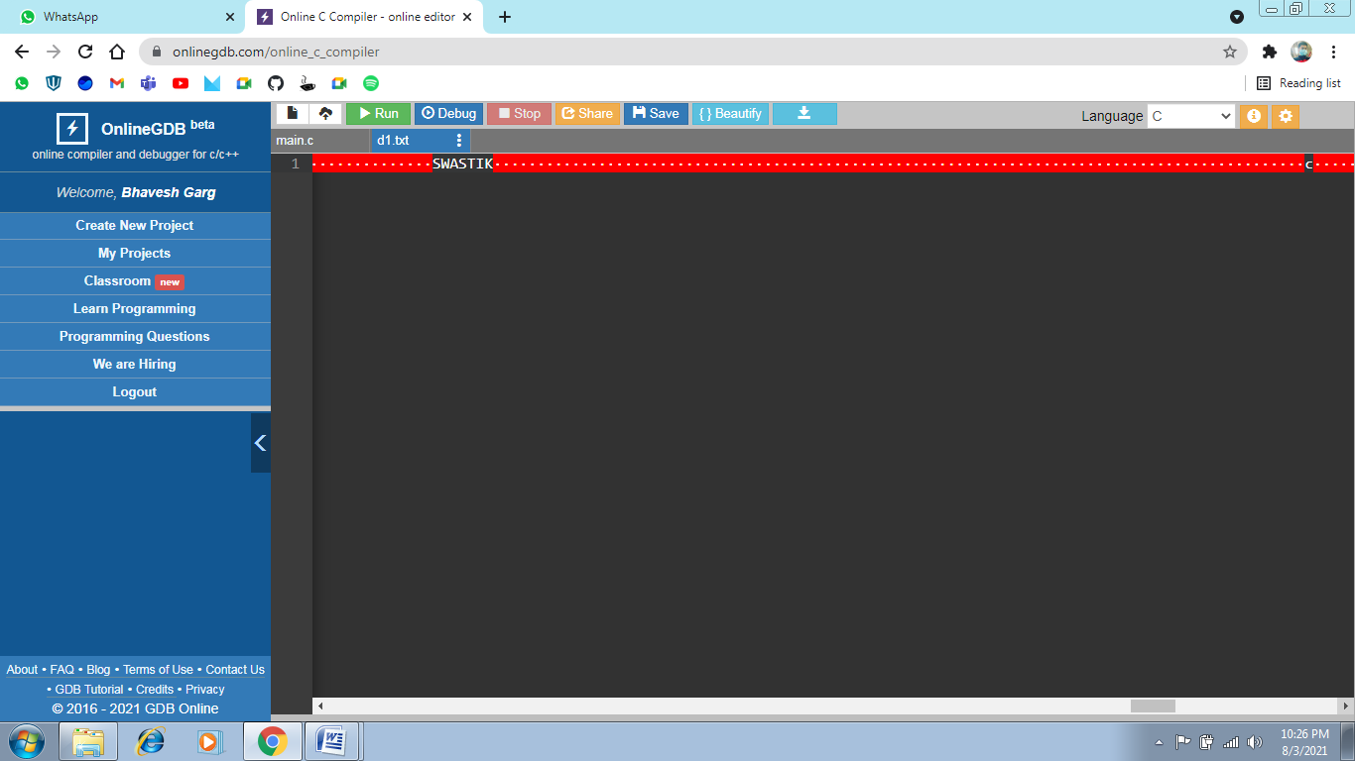

1. Using file operation create, display, modify, insert and delete records for employee system.

*SOURCE CODE*

#include <stdio.h>

#include <stdlib.h>

struct employee

{

int id;

char name[30];

int age;

};

struct employee e[3];

FILE *f1, *f2; //f1 for read and f2 for write

int i;

void add()

{

f2 = fopen("emp.txt", "w");

for (i = 0; i < 3; i++)

{

printf("\n Enter ID : ");

scanf("%d", &e[i].id);

printf("\n Enter Name : ");

scanf("%s", &e[i].name);

printf("\n Enter Age : ");

scanf("%d", &e[i].age);

fprintf(f2, "\n ID = %d, Name = %s, Age = %d", e[i].id, e[i].name, e[i].age);

}

fclose(f2);

}

void disp()

{

f2 = fopen("emp.txt", "r");

for (i = 0; i < 3; i++)

{

fscanf(f2, "%d %s %d", e[i].id, e[i].name, e[i].age);

printf("\n ID = %d", e[i].id);

printf("\n Name = %s", e[i].name);

printf("\n Age = %d", e[i].age);

}

fclose(f2);

}

void search()

{

int e_id, count = 0;

f2 = fopen("emp.txt", "r");

printf("\n Enter the Employee ID to search record : ");

scanf("%d", &e_id);

for (i = 0; i < 3; i++)

{

fscanf(f2, "%d %s %d", e[i].id, e[i].name, e[i].age);

if (e_id == e[i].id)

{

printf("\n Employee ID : %d", e[i].id);

printf("\n Employee Name : %s", e[i].name);

printf("\n Employee Age : %d", e[i].age);

count = 1;

}

}

if (count == 1)

{

printf("\n Record found");

}

else

{

printf("\n Record not found");

}

fclose(f2);

}

void del()

{

int e_id, temp;

char ch;

f2 = fopen("emp.txt", "r");

f1 = fopen("emp2.txt", "w");

printf("\n Enter the ID to delete account : ");

scanf("%d", &e_id);

for (i = 0; i < 3; i++)

{

while (fscanf(f2, "%d %s %d", e[i].id, e[i].name, e[i].age))

{

temp = e[i].id;

if (e_id != temp)

{

fprintf(f1, "\n ID = %d, Name = %s, Age = %d", e[i].id, e[i].name, e[i].age);

}

}

}

fclose(f1);

fclose(f2);

remove("emp.txt");

rename("emp2.txt", "emp.txt");

printf("\nRECORD DELETED\n");

}

int main()

{

int x;

do

{

printf("\n Main Menu");

printf("\n 1.Add Record");

printf("\n 2.Display Record");

printf("\n 3.Modify Record");

printf("\n 4.Search Record");

printf("\n 5.Delete Record");

printf("\n 6.Exit");

printf("\n Enter your choice : ");

scanf("%d", &x);

switch (x)

{

case 1:

add();

break;

case 2:

disp();

break;

case 4:

search();

break;

case 5:

del();

break;

case 6:

exit(1);

break;

}

} while (1);

return 0;

}

*OUTPUT*



